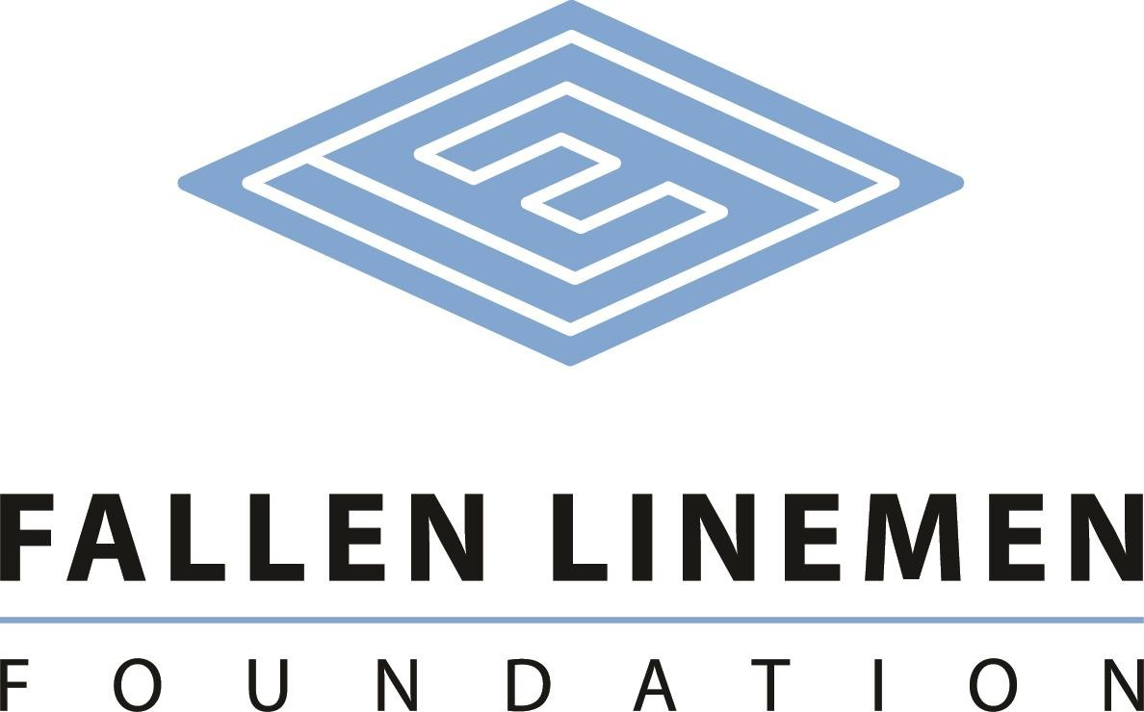

BILLY JONES MEMORIAL SCHOLARSHIP

The Billy Jones Memorial Scholarship has been created to assist students that are the children of active linemen interested in pursuing a college education. Three $2,000 scholarships will be offered to qualifying students to pursue their education in a secondary school. This scholarship honors the many years of dedication, hard work and support of Billy Jones. It is made possible by contributions from ElectriCities and NCAMES.

Eligible students must:

- be a permanent resident of North Carolina.
- have completed a Free Application for Federal Student Aid (FAFSA) application.
- be a high school senior or have a high school diploma from an accredited school or GED equivalent.
- have completed this application for scholarship.
- be enrolled full-time.
- provide a copy of student’s transcript.
- demonstrate financial need.
- demonstrate academic performance.
- demonstrate community or school related activities.

Scholarship recipients will be selected by a committee of non-utility related representatives. The committee will consider financial need (40%), as demonstrated by the Free Application for Federal Student Aid (FAFSA); merit (50%), as determined by academic performance; and community service (10%).

Proceeds for the scholarship will be disbursed directly to the Cashier’s office of the student’s college for student expenses.

Name ________________________________________________________________________

Address ______________________________________________________________________

City _____________________________________________State _______ Zip _____________

Birthdate _________________Home Phone ___________________Cell Phone _____________

E-mail _______________________________________________________________________

Are you a resident of North Carolina? Yes ____No ___ How long? ____________________

Number of people in household _______Other children in college? Yes ______No ____
How many? ________________

What high school did you or will you graduate? _______________________________________
What year did or will you graduate high school? ______________________________________

College you will be attending _____________________________________________________

Do you have a parent that is an electric utility lineman? Yes _____No______

If yes, what utility? _____________________________________________________________

Where did you hear about us? ____________________________________________________

Please describe your career goals.
____________________________________________________________________________
____________________________________________________________________________
____________________________________________________________________________
____________________________________________________________________________
Please write a descriptive paragraph that indicates why you believe you should be selected as a scholarship recipient.
____________________________________________________________________________
___________________________________________________________________________________
___________________________________________________________________________________
___________________________________________________________________________________
___________________________________________________________________________________
___________________________________________________________________________________
___________________________________________________________________________________

Please provide a descriptive list of your extracurricular activities.
____________________________________________________________________________
____________________________________________________________________________
____________________________________________________________________________
Disclaimer: A total of five scholarships are given annually to qualifying students (two) enrolled in an Electrical Lineman Program and children of linemen (three) attending the college of their choice. If there are not enough qualified candidates in either group, scholarships may be distributed among qualifying students of either group.
I understand that the information on this form as well as my transcripts will be reviewed by the scholarship selection committee. If I am awarded a scholarship, I hereby give permission for the release of the use of my name and photographic image to promote the Fallen Linemen Foundation.

Signatures:
Applicant __________________________________________________ Date: ___________

Chair of Selection Committee _________________________________ Date: ___________

Mail all materials to:

Fallen Linemen Foundation
Attention: Mr. Ed Hurst
P O Box 634
Cary, NC 27512

