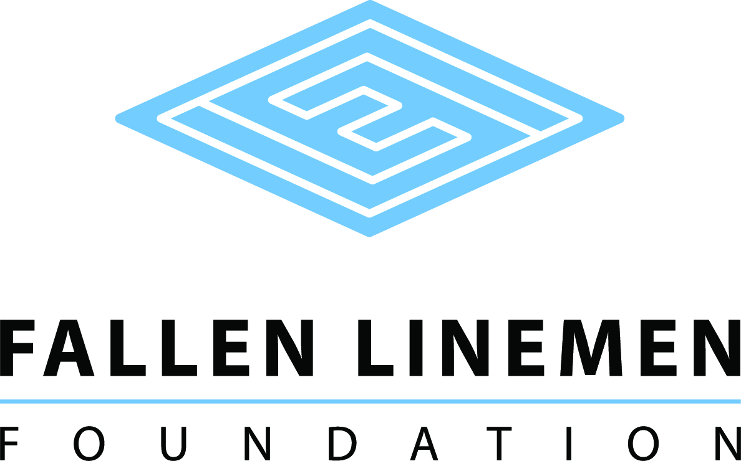

CHIEF RICHARD BROWNE SCHOLARSHIP APPLICATION

The Fallen Linemen Foundation Scholarship was created to assist students that are the children of active linemen interested in pursuing a college education. The $1,000 scholarship (one) will be offered to the qualifying student to pursue his/her education in a secondary school. This scholarship is made possible by contributions from Advocates MC, honoring Chief Richard Browne.
The eligible student must:
- be a permanent resident of South Carolina.
- have completed a Free Application for Federal Student Aid (FAFSA) application.
- be a high school senior or have a high school diploma from an accredited school or GED equivalent.
- have completed this application for scholarship.
- be enrolled full-time.
- provide a copy of student’s transcript.
- Demonstrate financial need.
- Demonstrate academic performance.
- Demonstrate community or school related activities.
The scholarship recipient will be selected by a committee of non-utility related representatives. The committee will consider financial need (40%), as demonstrated by the Free Application for Federal Student Aid (FAFSA); merit (50%), as determined by academic performance; and community service (10%).
Proceeds for the scholarship will be disbursed directly to the Cashier’s office of the student’s college for student expenses.
Name ______________________________________________________________________________
Address _____________________________________________________________________________

City _________________________________________________ State ________ Zip _________

Birthdate ______________Home Phone ____________________ Cell Phone ______________

E-mail ______________________________________________________________________________

Are you a resident of South Carolina? ____ Yes ____ No How long? __________________

Number of people in household _____ Other children in college? ____ Yes _____ No How many? ____

What high school did you or will you graduate? _______________________________________

What year did or will you graduate high school? ______________________________________

College you will be attending _____________________________________________________

Do you have a parent that is an electric utility lineman? ____ Yes ____ No

If yes, what utility? _____________________________________________________________________

Please describe your career goals.

______________________________________________________________________________

______________________________________________________________________________

______________________________________________________________________________

______________________________________________________________________________

______________________________________________________________________________

Please write a descriptive paragraph that indicates why you believe you should be selected as a scholarship recipient.

______________________________________________________________________________

______________________________________________________________________________

______________________________________________________________________________

______________________________________________________________________________

______________________________________________________________________________

Please provide a descriptive list of your extracurricular activities.

______________________________________________________________________________

______________________________________________________________________________

______________________________________________________________________________I understand that the information on this form as well as my transcripts will be reviewed by the scholarship selection committee. If I am awarded a scholarship, I hereby give permission for the release of the use of my name and photographic image to promote the Fallen Linemen Foundation.

Signatures:

Applicant __________________________________________________ Date: ___________

Chair of Selection Committee _________________________________ Date: ___________

Mail all materials to:

Fallen Linemen Foundation
Attention: Mr. Ed Hurst
P O Box 634
Cary, NC 27512

