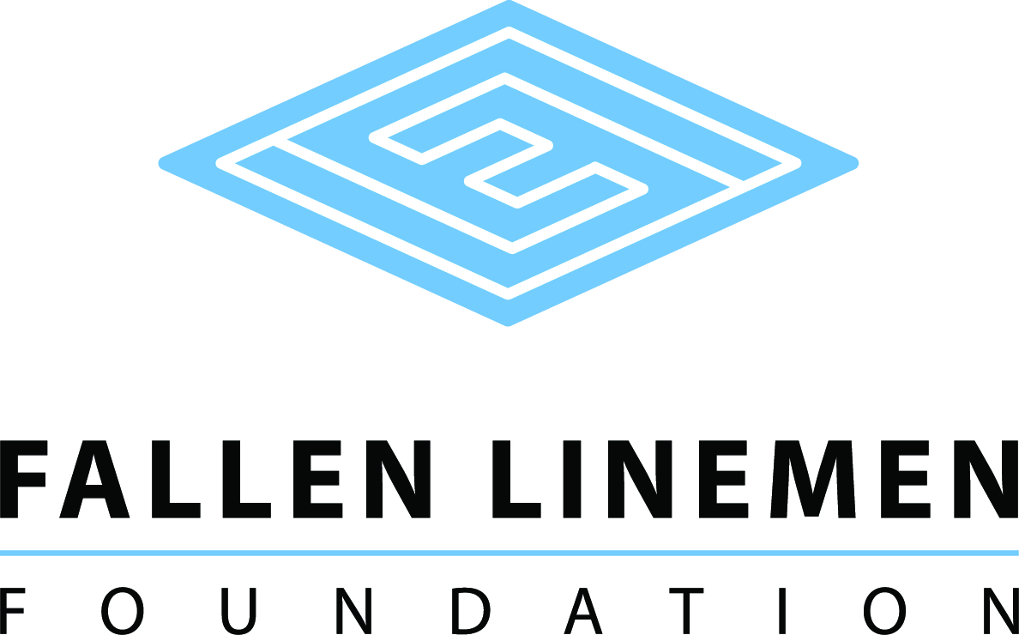

GARY WAYNE PECK SCHOLARSHIP APPLICATION

The Gary Wayne Peck Fallen Linemen Foundation Scholarship was created to assist students that are the children of active linemen or linemen employed by Southern Maryland Electric Cooperative interested in pursuing a college education. The $1500 scholarship (one) will be offered to the qualifying student to pursue his/her education in a secondary school.
The eligible student must:
- be a permanent resident of Virginia or Maryland;
- have completed a Free Application for Federal Student Aid (FAFSA) application;
- be a high school senior or have a high school diploma from an accredited school or GED equivalent;
- have completed this application for scholarship;
- be enrolled full-time;
- provide a copy of student’s transcript;
- Demonstrate financial need;
- Demonstrate academic performance;
- Demonstrate community or school related activities.
The scholarship recipient will be selected by a committee of non-utility related representatives. The committee will consider financial need (40%), as demonstrated by the Free Application for Federal Student Aid (FAFSA); merit (50%), as determined by academic performance; and community service (10%).
Proceeds for the scholarship will be disbursed directly to the Cashier’s office of the student’s college for student expenses.
Name ______________________________________________________________________________
Address _____________________________________________________________________________

City _________________________________________________ State ________ Zip _________

Birthdate ______________Home Phone ____________________ Cell Phone ______________

E-mail ______________________________________________________________________________

Are you a resident of Virginia or Maryland? ____ Yes ____ No How long? ______________

Number of people in household _____ Other children in college? ____ Yes _____ No How many? ____

What high school did you or will you graduate? _______________________________________

What year did or will you graduate high school? ______________________________________

College you will be attending _____________________________________________________

Do you have a parent that is an electric utility lineman? ____ Yes ____ No

If yes, what utility? _____________________________________________________________________

Please describe your career goals.

______________________________________________________________________________

______________________________________________________________________________

______________________________________________________________________________

______________________________________________________________________________

______________________________________________________________________________

Please write a descriptive paragraph that indicates why you believe you should be selected as a scholarship recipient.

______________________________________________________________________________

______________________________________________________________________________

______________________________________________________________________________

______________________________________________________________________________

______________________________________________________________________________

Please provide a descriptive list of your extracurricular activities.

______________________________________________________________________________

______________________________________________________________________________

I understand that the information on this form as well as my transcripts will be reviewed by the scholarship selection committee. If I am awarded a scholarship, I hereby give permission for the release of the use of my name and photographic image to promote the Fallen Linemen Foundation.

Signatures:

Applicant __________________________________________________ Date: ___________

Chair of Selection Committee _________________________________ Date: ___________

Mail all materials to:

Fallen Linemen Foundation
Attention: Mr. Ed Hurst
P O Box 634
Cary, NC 27512

