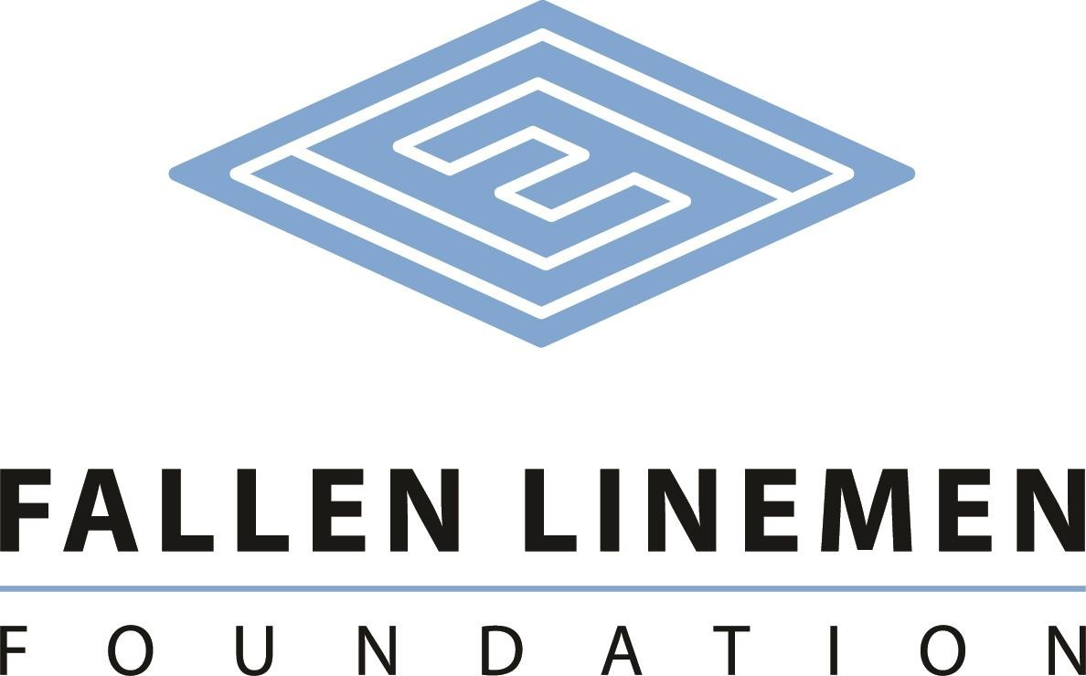

The CEEUS Lineman Legacy Scholarship

The CEEUS Lineman Legacy Scholarship has been created to assist students that are the children of an active line worker interested in pursuing a college education. Three $1,000 scholarships will be offered to qualifying students to pursue their education in a secondary school. It is made possible by contributions from CEEUS.

Eligible students must:

* be a permanent resident of South Carolina.
* have completed a Free Application for Federal Student Aid (FAFSA) application.
* be a high school senior or have a high school diploma from an accredited school or GED equivalent.
* have completed this application for scholarship.
* be enrolled full-time.
* provide a copy of the student’s transcript.
* demonstrate financial need.
* demonstrate academic performance.
* demonstrate community or school related activities.

Scholarship recipients will be selected by a committee of non-utility related representatives. The committee will consider **financial need (40%)**, as demonstrated by the Free Application for Federal Student Aid (FAFSA); **merit (50%)**, as determined by academic performance; and community service (10%).

Proceeds for the scholarship will be disbursed directly to the Cashier’s office of the student’s college for student expenses.

Name ________________________________________________________________________

Address ______________________________________________________________________

City _____________________________________________State _______ Zip _____________

Birthdate _________________Home Phone **___________________**Cell Phone _____________

E-mail _______________________________________________________________________

Are you a resident of South Carolina? Yes ____No **___** How long? ____________________

Number of people in household **_______**Other children in college? Yes **______**No **____**

How many? **________________**

What high school did you or will you graduate? **_______________________________________**

What year did or will you graduate high school? ______________________________________

College you will be attending _____________________________________________________

Do you have a parent that is an active electric utility line worker in SC? Yes **_____**No**______**

If yes, what utility? **_____________________________________________________________**

Where did you hear about us? **____________________________________________________**

Please describe your career goals.

**____________________________________________________________________________**

**____________________________________________________________________________**

**____________________________________________________________________________**

**____________________________________________________________________________**

Please write a descriptive paragraph that indicates why you believe you should be selected as a scholarship recipient.

**____________________________________________________________________________**

**___________________________________________________________________________________  
___________________________________________________________________________________  
___________________________________________________________________________________**

**___________________________________________________________________________________**

**___________________________________________________________________________________**

**___________________________________________________________________________________**

Please provide a descriptive list of your extracurricular activities.

**____________________________________________________________________________**

**____________________________________________________________________________**

**____________________________________________________________________________**

**I understand the information on this form as well as my transcripts will be reviewed by the scholarship selection committee. If I am awarded a scholarship, I hereby give permission for the release of the use of my name and photographic image to promote the Fallen Linemen Foundation.**

**Signatures:**

**Applicant __________________________________________________ Date: ___________**

**Chair of Selection Committee _________________________________ Date: ___________**

Mail all materials to:

Fallen Linemen Foundation

**Attention:** Mr. Ed Hurst

P O Box 634

Cary, NC 2751